|  |
| --- |
| Crafty Cuts Laser |
| System Installation |
| Version 1.1 |
|  |

|  |
| --- |
| Jack, Fiona and Nasser  2-4-2016 |

# Introduction

This guide will serve the purpose of setting up the system. This document will run step by step what is required in order to install the system on the Hoopla servers. This is the way we recommend the system to be uploaded, primarily because it’s very easy,

# Installing the system

In order to install the system the user will need the following things. The Database SQL file, and the system code file (shown below), a working hosting service and domain.

## Step 1: Login to your Service provider

Go to: <https://www.hooplahosting.com/>

Alternatively skip this process and go straight to the CPanel by following this link: <http://103.49.205.13:2082/>

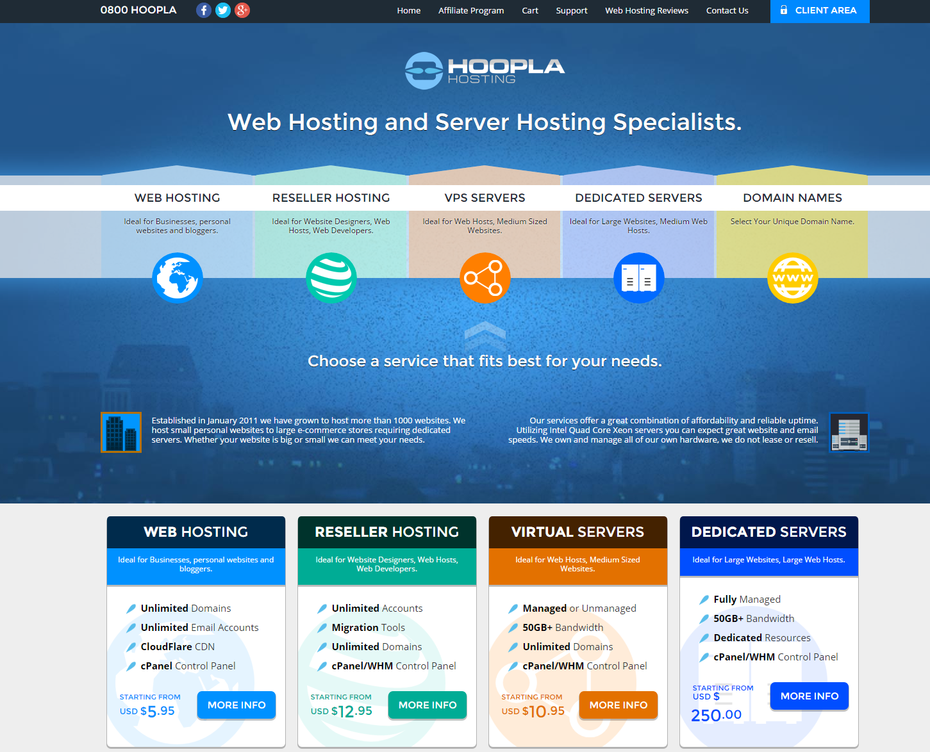

## Login

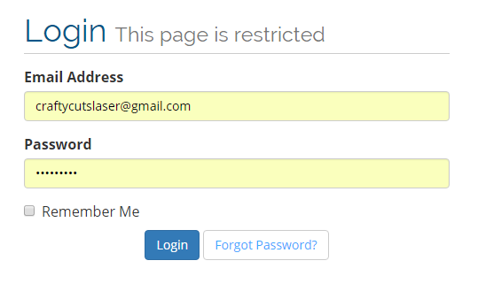

## Step 2: Navigate to the CPanel

By first clicking on services followed by selecting your active service. From there you select the craftycutslaser.com service.

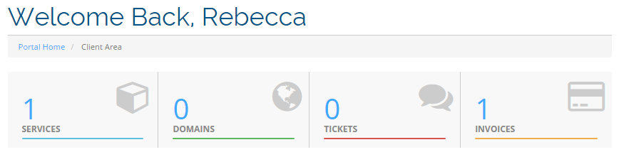

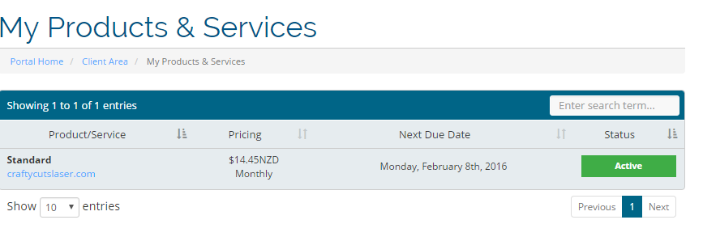

After you select the correct service you should see this page.

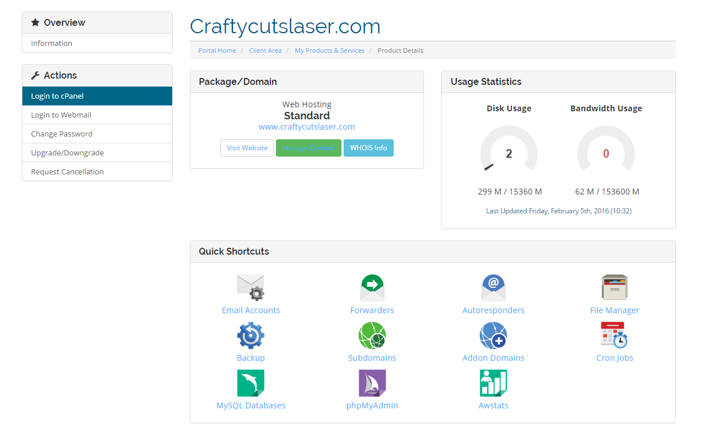

Select login to cPanel in the left hand menu. This will take you to the control panel.

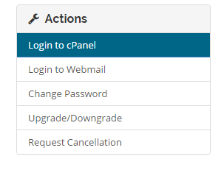

## Step 3: Prepare the server for installation of cake PHP

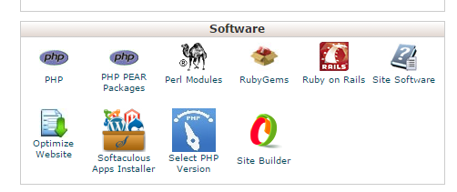

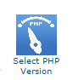

Select, Select PHP Version. From here, select PHP version 5.6 or above. After you set it as current, then click save and return back to the control panel.

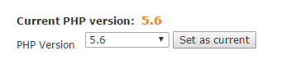



## Step 4: Install cake

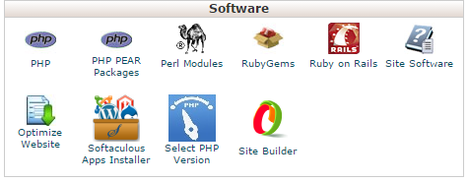

Select Softaculous App Installer, this will take you to another page. Here you can search for CakePHP.

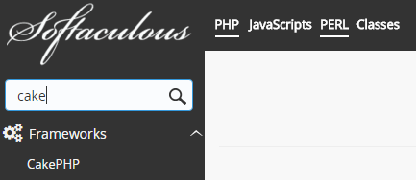

Select Cake PHP and then continue by selecting install. The domain should be the url of the website. Database name should be set as **localdatabase**. Automated backups should be daily and set to a comfortable number 7 is good. 10 will allow for a week and a half of backups before the oldest backup is saved over.

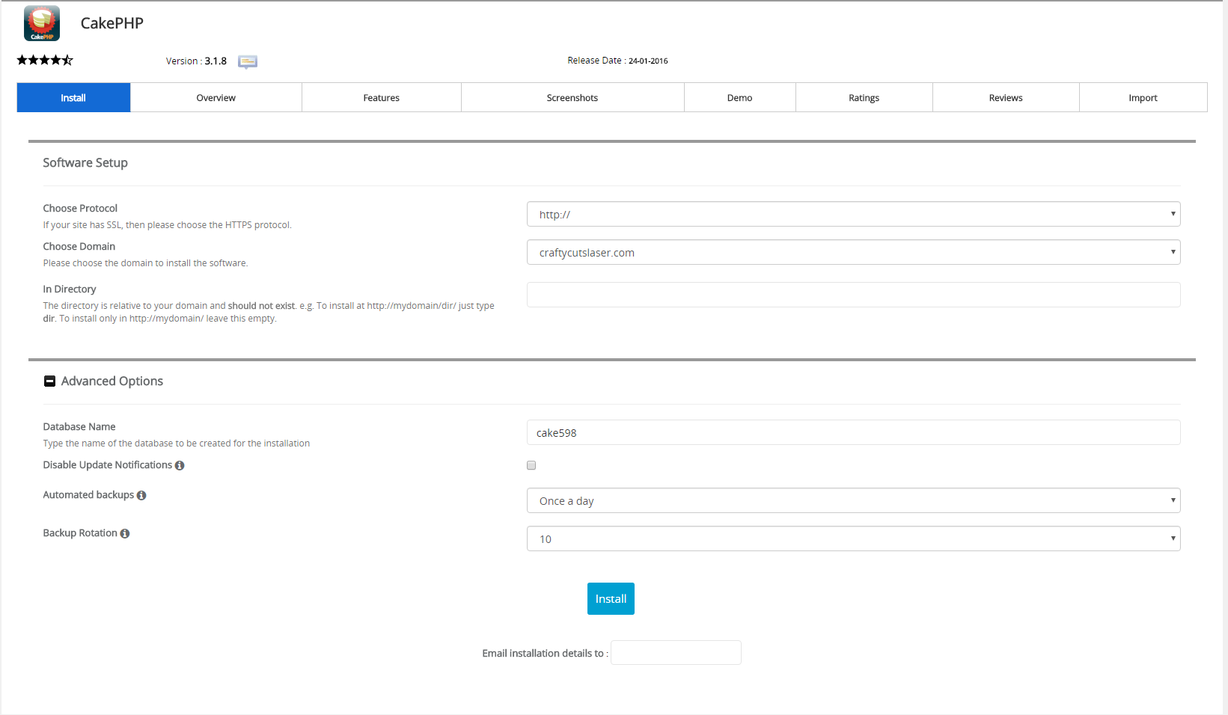

## Step 5: Installing the SQL database

Go to PHP my Admin located in the databases section of the cPanel.

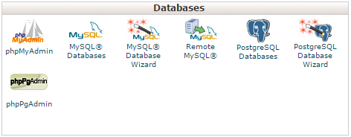

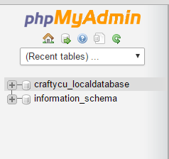

Select the Database that was created and then import the sql document that was provided called localdatabase.sql.

## Step 6: Transferring the files across

From here, go back to the cPanel and then select File manager. A zip folder has been provided called craftycutslaser.zip. Press upload, navigate to that zip file and upload it to the system. Select Overwrite existing files. From here, unzip the file and it will overwrite itself, this will replace the fresh cakePHP installation with the original.

